WAGO DI/DO with LS6 2.14

Content

WAGO with LS6-P2 (Rel 2.14) and up to 32 DI/DO at **CAN1** 1

HW-Setup: 1

Settings WAGO (for this example): 2

Settings LS6 2

WAGO with LS6-P1 **CAN1** 4

WAGO with LS6-P2 **CAN2** 5

Internal 5

Indices LS6 5

Data: 5

CONFIGURATION String: W32D: 6

# WAGO with LS6-P2 (Rel 2.14) and up to 32 DI/DO at **CAN1**

## HW-Setup:

Tested with LS6 **P2** 2.14

Wago devices

**DOs:**

1x16

1x8

1x4

**DIs**

1x16

1x8

1x4

## Settings WAGO (for this example):

WAGO needs to be configured. The easiest way to configure WAGO is with the **easYgen**.

Connect WAGO hardware (configured to 250 kbd and Node ID 3) to CAN 2 of the easYgen.

* Set 15320 to “W32D”
* Wait 30 sec
* Reboot
* Set 15134 to yes

Ein Bild, das Text, Screenshot, Schrift, Design enthält.

## Settings LS6

**CAN 1 General settings**

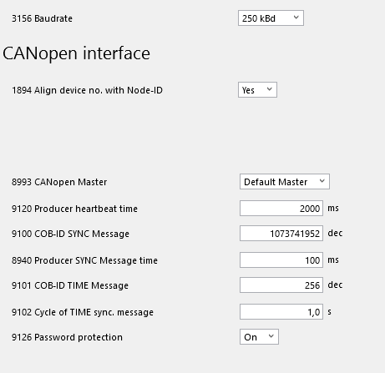

WAGO needs the **SYNC message** at ID 80h to transmit any data. For this reason9100 is to configure to 1073741952 (= 4000 0080h). This is 80h and bit 30 set to TRUE that LS6 transmits the SYNC MESSAGE at ID 80h

In the example 8940 is configured to 100 ms, this means WAGO transmits the data with 100 ms rate. This must be considered for the configuration of the CAN 1 monitoring and the RPDO 1 Event timer ID 9121.

**TPDO CAN 1: for example:**

Ein Bild, das Text, Screenshot, Schrift, Zahl enthält.

**RPDO CAN 1 for example:**

Ein Bild, das Text, Screenshot, Schrift, Zahl enthält.

# WAGO with LS6-P1 **CAN1**

Is working too with similar configuration, but of course only with up to 16 chanels.

# WAGO with LS6-P2 **CAN2**

Is **not** working because:

* RPDOs, TPDOs: no access
* Synch message: no access
* Node ID: no access